Lab 4

#include "library.h"

const double g = 9.807;

double projectileh(int v, double t, double a){

double h = v*t*(sin(a)) - (0.5*g)*(t*t);

return h;

}

void tabulation(int v, double t, double a){

double d = v*t*cos(a);

int t_elapsed = ((2)*(v) / g);

move_to(0,300);

if (t <= t_elapsed, (int)projectileh(v, t, a) >= 0){

cout << " After " << t << " second(s), height is " << (int)projectileh(v, t,a) << " metres" << endl;

set_pen_width_color(5,color::red);

draw_point((t)*50, (500-projectileh(v, t,a)/2));

tabulation(v, t + 0.05,a);

}

}

void drawside(double angle, int length) {

turn_right_by_degrees(angle);

draw_distance(length);

}

void circle(int n, int numsides, int len) {

double pi = acos(-1.0);

if (n > 0) {

drawside(360.0 / numsides, len);

circle(n - 1, numsides, len);

}

}

void cannon(){

set_pen_width(3);

move_to(45, 495);

draw_to(0, 460);

draw_to(100, 400);

move_to(45, 495);

draw_to(120, 420);

draw_to(100, 400);

move_to(60, 470);

circle(36, 36, 3);

}

void castle(int x){

move_to(880, 500);

draw_distance(x);

turn_right_by_degrees(90);

draw_distance(x);

turn_right_by_degrees(90);

draw_distance(x);

move_relative(0, -x / (5/2));

move_relative(-30, 0);

draw_distance(10);

turn_right_by_degrees(90);

draw_distance(15);

turn_right_by_degrees(90);

draw_distance(10);

turn_right_by_degrees(90);

draw_distance(15);

move_relative(10, 0);

draw_distance(15);

turn_right_by_degrees(90);

draw_distance(10);

turn_right_by_degrees(90);

draw_distance(15);

turn_right_by_degrees(90);

draw_distance(10);

}

void main(){

make_window(950, 500);

cannon();

castle(50);

print("Enter wanted velocity: ");

const int velocity = read_double();

print("Enter wanted angle: ");

double Piangle = read_double()*(3.1415 / 180);

move_to(98, 415);

tabulation(velocity, 1.0,Piangle);

new_line();

cout << "The ball was in the air for: " << (int)((2)*(velocity) / g) << " seconds total.";

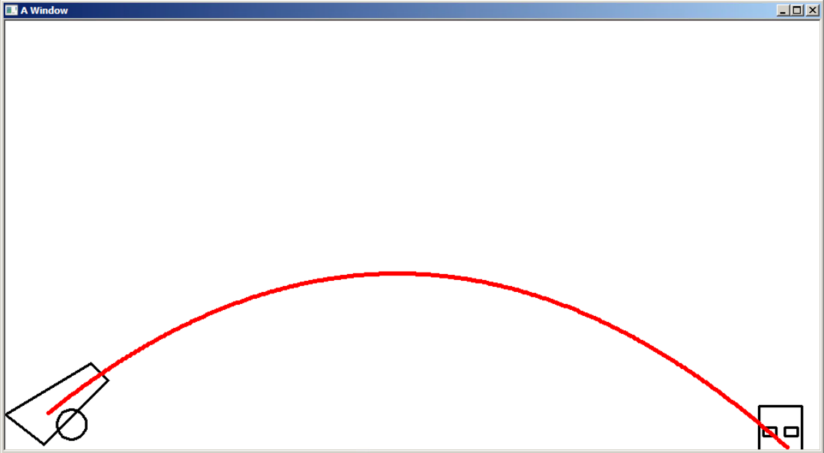

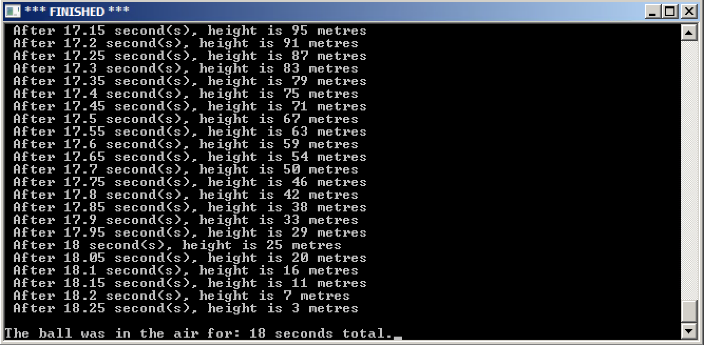

}

I couldn’t get the projectile to shoot from the center of the cannon barrel, and couldn’t find out how to create a function that acknowledges the ending of the projectile relevant to the placement of the castle.